Fingerprint module specification

ARA-EM01

Aratek Biometrics Technology Co. Ltd.

- General view
The ARA-EM01 is high performance fingerprint module developed by Aratek Biometrics Technology Co, Ltd .it has many features : easy restructure, powerful functions, compatible with PC，and multiple-functions in one module: Fingerprint enrollment, image process, characters acquisition, fingerprint template creation, fingerprint template storage, fingerprint compare (1: 1, 1: N), fingerprint delete. This module can work with different devices based on UAWRT such as PC, SCM and so on. Only easy circuits and fingerprint module can enhance your product into fingerprint authentication power. It is widely used by electronics business, information security, access control, identity authentication and other security industry.

- Photo

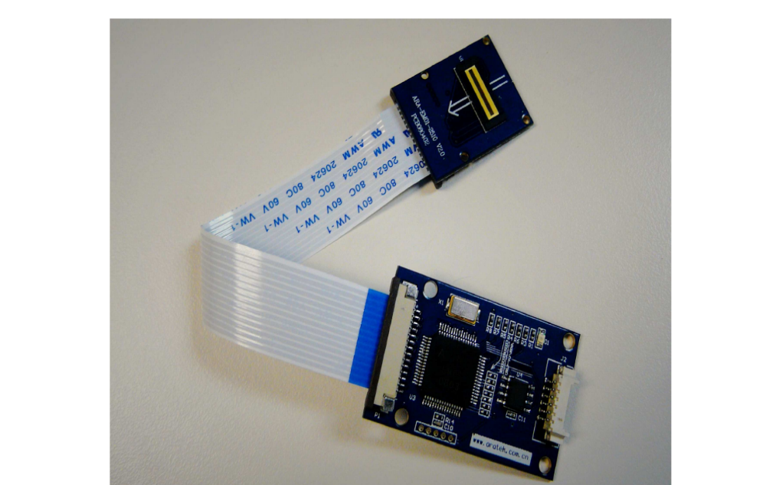

- Application solution
1 When ARA-EM01 is embedded into your system, the other functions will be controlled by MCU Controller, so developer can realize his own function logic, user interface and communication port through hard ware and soft ware development, such as fingerprint time and attendance and so on.

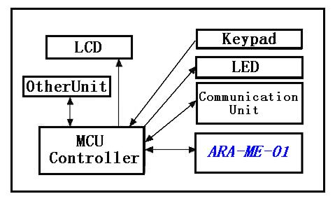

2 Expand the port such as RS485, Wiegand, even GPRS wireless communication with central controller outside by MCU in the central controller system.
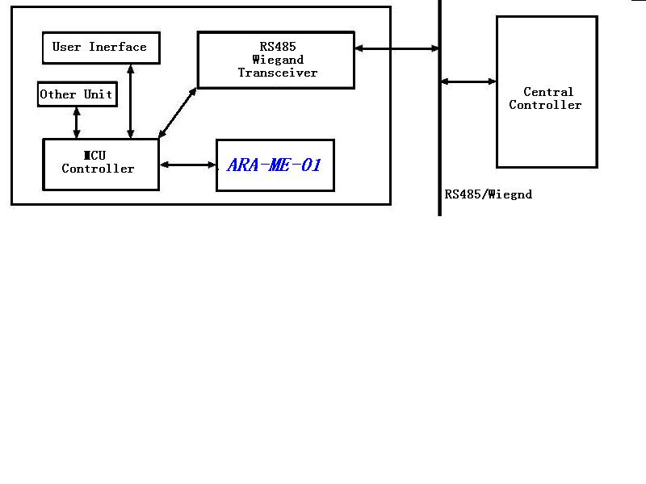

- hardware spec

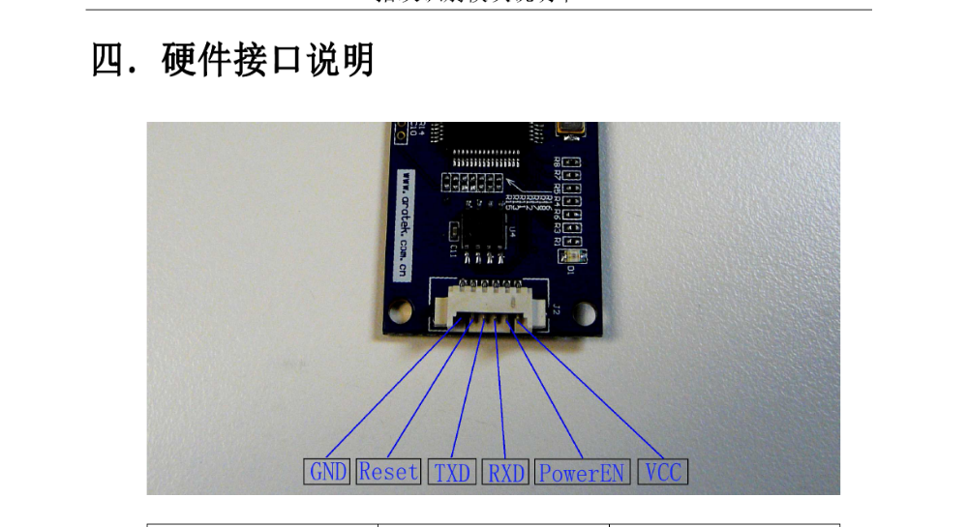

Remark：
pin | Name | spec
1、 | GND | Grand
2、 | Reset | Module reset control
3 | TXD | Serial sender
4 | RXD | Serial receiver
5、 | PowerEN | Power control
6、 | VCC | 5V
1 reset signal is the low level, the level width is bigger than 10ms.

2 high level turn on the power, low level turn off the power.

5 software port spec
    - Communication port UART (Universal Asynchronous Serial Port), 9600bps to 115200bps (option), start with 1 bit, stop with 1 bit, no check bit.

    - Communication protocol Module stays in slave mode, and host can direct the module work by different command. All the command of the host and response of the module and data transfer are in standard data pack. Host must pack and analyze the command and the data in standard format.

6 fingerprint authentication performance

item | spec
Sensor | AES2510
Image | 256*288
Resolution | 500DPI
Register time | <3秒
Math time （1：1） | <0.1秒
Math time （1：N） | <0.5秒
FRR | <0.1%
FAR | <0.001%
Fingerprints capacity | 160 fingerprints

7other spec

item | Symbol | min | classic | max | Measure
Work Voltage | Vn | 4.5 | 5 | 5.5 | V
Work Current | In | 50 | 60 | 80 | mA
Sleep current | Is | 9 | 10 | 12 | uA
Work Temperature | Tn | －20 |  | 70 | ℃
Humility | Hn | 30 |  | 120 | ℉
Module size | Ln | 40mm*25mm 20mm*25mm |  |  | mm

Interface

Type | Description
UART | 3.3V CMOS level  Baud rates up to 921.6kbps (factory default is 115.2kbps)  RS232/422/485 supported via additional level converter
Digital I/O | 3.3V CMOS level  8 ports separately configurable  26bit Wiegand I/O supported via additional level converter

Connector Specifications

Connector | Usage
J1 | Host interface port I
J2 | Host interface port II (Molex 53261-8090 compatible)
J3 | Debug port for factory use only
J4 | Sensor interface port, 20 pin FPC/FFC

8 Command summary

8.1 Flash storage structure:

Address | Spec | Size
0x0000-0x7fff | Some codes | 32k
0x8000-0x8fff | System parameters storage | 4k
0x9000-0xffff | Fingerprint database | 28k- the end

8.2 System parameters storage area

Flash physical address | Page | Spec | remark
0x8000 | 0 | Reserve
0x8200 | 1 | Parameter list
0x8400 | 2 | User notebook
0x8600 | 3 | Reserve
0x8800 | 4 | Reserve
0x8a00 | 5 | Reserve
0x8c00 | 6 | Reserve
0x8e00 | 7 | Reserve

8.3 Command spec
PS_GetImage | Code: 01H | Function: read image from the sensor and store it in the image buffer.
PS_GenChar | Code: 02H | Function: create fingerprint features document through the image and store in CharBuffer1 or CharBuffer2.
PS_Match | Code: 03H | Function: compare the features documents in the CharBuffer1 and Charbuffer2.
PS_Search | Code: 04H | Function: search the fingerprint database according to the features document in the CharBuffer1 or CharBuffer2.
PS_RegModel | Code: 05H | Function: create fingerprint template according to the features documents in the CharBuffer1 and CharBuffer2.
PS_StoreChar | Code: 06H | Function: store the template into the flash fingerprint database from the features buffer.
PS_LoadChar | Code：07H | Function: read template to features buffer from flash fingerprint database.
PS_UpChar | Code: 08H | Function: transfer the data in the features buffer to the PC.
PS_DownChar | Code: 09H | Function: load a template from PC to features buffer.
PS_DeletChar | Code: 0CH | Function: delete a template in the flash fingerprint database.
PS_Empty | Code: 0DH | Function: clear flash fingerprint database
PS_WriteReg | Code: 0EH | Function: write SSR
PS_ReadSysPara | Code: 0FH | Function: read basic system parameters
PS_SetPwd | Code: 12H | Function: set device password.
PS_VfyPwd | Code: 13H | Function: verify device password.
PS_GetRandomCode | Code: 14H | Function: get random code
PS_SetChipAddr | Code: 15H | Function: set the chip address
PS_WriteNotepad | Code: 18H | Function: write notepad
PS_ReadNotepad | Code: 19H | Function: read notepad
PS_ValidTempleteNum | Code: 1dH | Function: read the template number from the flash

8.4 Pack structure
8.4.1 Send command

The packet flag=01 command packet
The packet flag=02 data packet, and data packet followed
The packet flag=08 the last data packet
All the data packet’s head is 0xEF01,0xFFFFFFFF
01 command packet format
Name | Packet head | Device address | Packet  Flag | Packet  Length | Command | Parameter 1 | …. | Parameter  N | Checksum
Size | 2bytes | 4bytes | 1 byte | 2bytes | 1byte | …… |  |  | 2 bytes
spec | 0xEF01 | xxxx | 01

02 data packet format
Name | Packet head | Device address | Packet  Flag | Packet  Length | Command | Parameter 1 | …. | Parameter  N | Checksum
Size | 2bytes | 4bytes | 1 byte | 2bytes | N bytes  …… |  |  |  | 2 bytes
spec | 0xEF01 | xxxx | 02

08 last data packet
Name | Packet head | Device address | Packet  Flag | Packet  Length | Command | Parameter 1 | …. | Parameter  N | Checksum
Size | 2bytes | 4bytes | 1 byte | 2bytes | N bytes  …… |  |  |  | 2 bytes
spec | 0xEF01 | xxxx | 08
·The data packet can’t run itself; it must follow the command packet or the response packet.
·Download or upload the data packet in the same format.
·Packet length = the total bytes quantity of from the packet length to the checksum，including checksum，but not including the bytes quantity of the packet length itself.
·Checksum is the summer of all the bytes quantity from the packet flag to checksum，including packet flag, neglect the rounding over 2bytes.

8.4.2 Command response
Response packet/data packet:
The Packet flag = 07 response packet
The packet flag = 02 data packet, and packet followed
The packet flag = 08 the last data packet
Response is to send report to host about the result and how the commands run; data packet can follow the response packet. The host can confirm situation about the command execution and receiving response packet.
Response packet format:
Name | Packet head | Device address | Packet  Flag | Packet  Length | Confirmation code | Parameter | Checksum
Size | 2bytes | 4bytes | 1 byte | 2bytes | 1 bytes | N bytes | 2 bytes
spec | 0xEF01 | xxxx | 07

9 Physical Dimensions

9.1 Main board
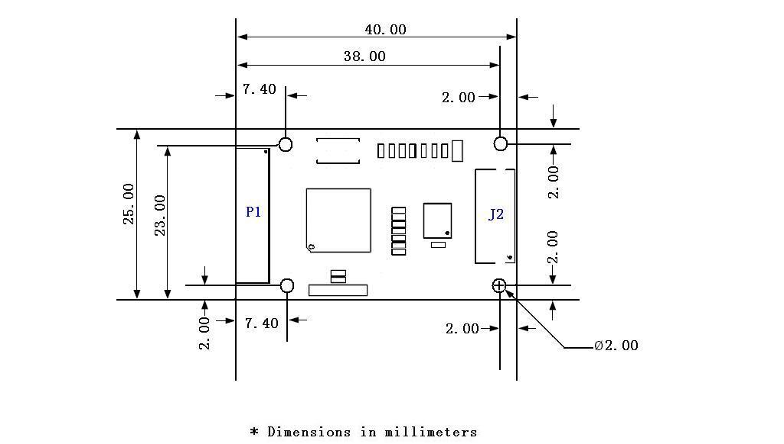

9.2 Sensor
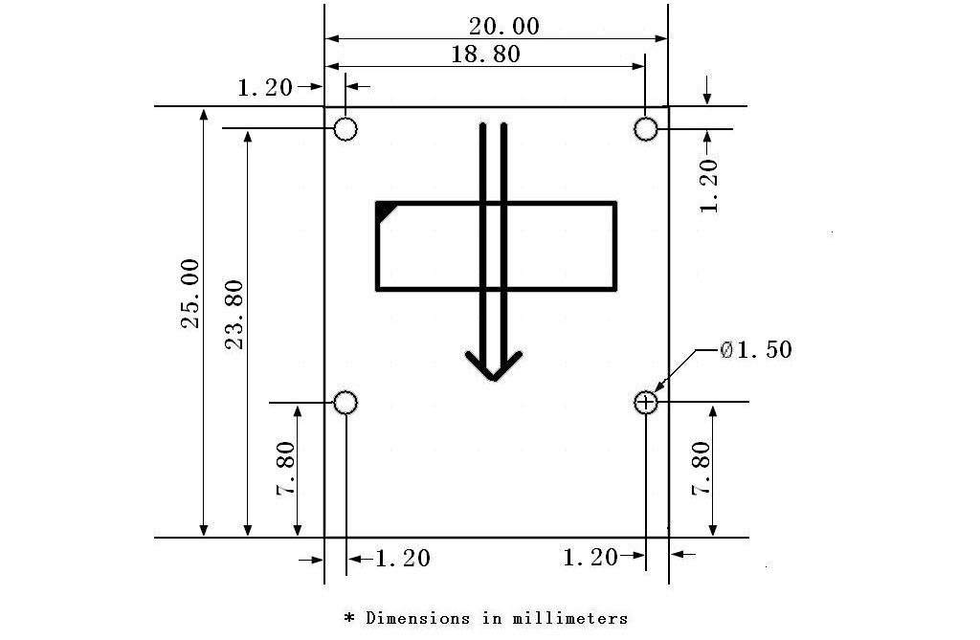

For more products information please log on www.aratek.com.cn, thanks for your support and welcome your good advice for improvement.

